**Project Design Phase-II**

**Technology Stack (Architecture & Stack)**

|  |  |
| --- | --- |
| Date | 6 March 2025 |
| Team ID | SWTID1741257108149874 |
| Project Name | FITFL |
| Maximum Marks | 4 Marks |

**Technical Architecture:**

The Deliverable shall include the architectural diagram as below and the information as per the table1 & table 2

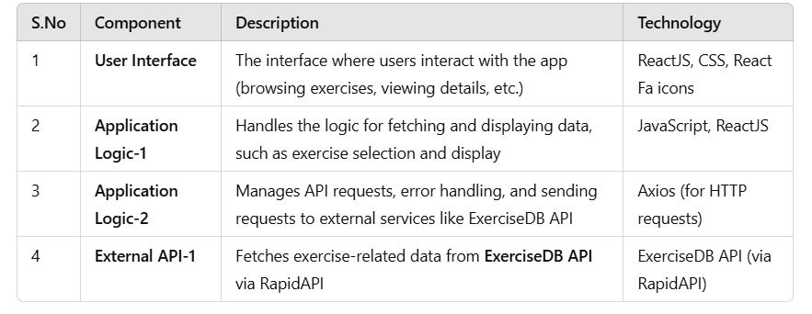

**Table-2: Application Characteristics:**

